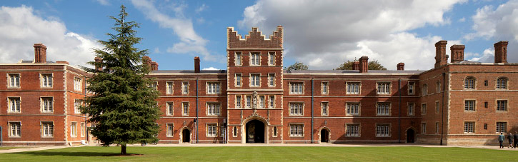
Jesus College, Cambridge, CB5 8BL
www.jesus.cam.ac.uk

Symposium Organising Committee
Cambridge: Mr Kourosh Saeb-Parsy
Kings College London: Prof Giovanna Lombardi
Oxford: Prof Kathryn Wood

UK Humanised Mouse Symposium

Meeting Report

Friday 25th September 2015
Hosted by the University of Cambridge, King’s College London and the University of Oxford
Programme
09:00 | Coffee & Registration | Prioress’s Room
19:50 | Welcome | Coleridge Room
 | Mr Kourosh Saeb-Parsy & Prof Giovanna Lombardi
10:00 | An introduction to the generation and use of humanised mice | Coleridge Room
 | Mr Kourosh Saeb-Parsy
10:15 | Regulation and public perception of humanised mouse research | Coleridge Room
 | Chair: Mr Kourosh Saeb-Parsy & Dr Eleanor Bolton
10:15 | Humanised mice: Regulatory considerations
 | Dr Martin Vinnell – Establishment License Holder at the University of Cambridge
10:30 | Humanised mice: public engagement and communication
 | Mr Tom Holder – Campaign Manager at Understanding Animal Research
10:45 | Generation and characterisation of humanised mice | Coleridge Room
 | Chair: Prof Giovanna Lombardi & Mr Gavin Pettigrew
10:45 | Humanised mouse models in transplantation – advantages and pitfalls
 | Mr Fadi Issa – University of Oxford
11:15 | Generation and characterisation of humanised mice from HLA-typed deceased human organ donors
 | Mr Kourosh Saeb-Parsy – University of Cambridge
11:45 | NOD/SCID/IL-2rγ null mice engrafted with human CD34+ stem cells: a model to investigate new strategies to induce tolerance in human islet transplantation
 | Dr Fang Xiao – Kings College London
12:15 | Establishing humanised models of NSG and NOG mice
 | Dr Aidan Synnott - Charles River Laboratories
13:00 | Lunch | Prioress’s Room
14:00 | Novel technologies in humanised mouse research | Coleridge Room
 | Chair: Prof Giovanna Lombardi & Mr Kourosh Saeb-Parsy
14:00 | Innovative preclinical research using humanized NSG Mice
 | Dr Brian Soper – Jackson Laboratories
14:45 | Neurotrophic factors control HSC survival and transplantation
 | Dr Henrique Veiga-Fernandes – StemCell2MAX
15:15 | Isolation and modulation of human HSCs
 | Dr Yvonne Diener – Miltenyi Biotec
15:45 | Coffee | Coleridge Room
16:00 | Experimental applications of humanised mice | Coleridge Room
 | Chair: Dr Joanna Hester & Dr Eleanor Bolton
16:00 | Innate immunity to viral infections in humanised mice
 | Dr Marcus Dorner – Imperial College London
16:30 | Humanised mouse models to study human Tregs in vivo
 | Miss Kate Milward – University of Oxford
16:45 | Using humanised mice to assess the induction of cell expansion by IL-2 and related variants
 | Dr Sarah Howlett – University of Cambridge
17:00 | Generation of allospecific regulatory T cells using chimeric antigen receptors to elicit targeted transplant tolerance
 | Mr Dominic Boardman – King’s College London
17:15 | Humanised mouse model of XenoGvHD to study the stability of human Tregs and the impact of immunosuppressive therapy on their functions
 | Dr Cristiano Scotta - King’s College London
17:30 | Summary & Conclusion | Coleridge Room
 | Mr Kourosh Saeb-Parsy

Meeting Report
Welcome
Mr Kourosh Saeb-Parsy (Cambridge) and Prof Giovanna Lombardi (KCL) welcomed the delegates to the inaugural UK Humanised Mouse Symposium. They re-iterated that the symposium was established in order to promote sharing of knowledge and expertise centred on the generation, characterisation and use of humanised mice, and specifically to promote multidisciplinary collaborations. Apologies and well wishes were received from Prof Kathryn Wood (Oxford), co-organiser of the meeting, who unfortunately was unable to attend the symposium.
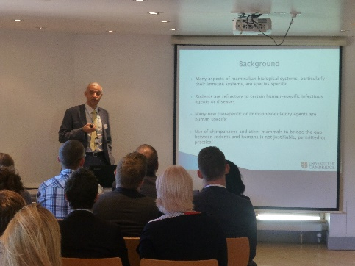
Introduction
Kourosh Saeb-Parsy (Cambridge) gave an overview of the need for humanised mouse models, their development, characterisation and potential applications. He outlined the main methods for the generation of humanised mice, before describing some of the challenges currently faced in this field. These included immunological, practical, regulatory and ethical, as well as economic considerations. He outlined some of the potential strategies that may be adopted to meet these challenges.
Regulation and public perception of humanised mouse research
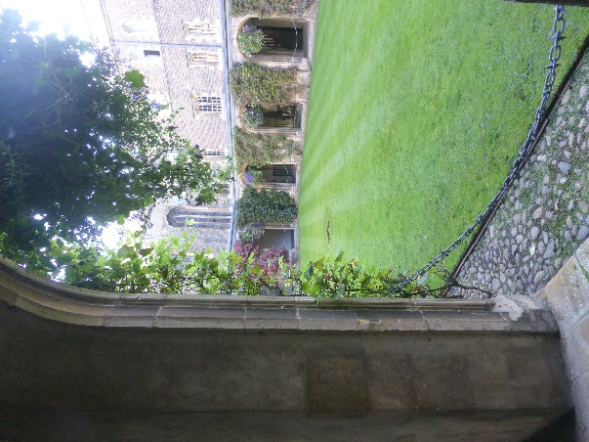
Dr Martin Vinnell (Cambridge) outlined the importance of regulation in this emerging field of research but reiterated that with appropriate engagement between regulators (including the Home Office) and researchers no significant regulatory hurdles were anticipated. The importance of identifying risks, understanding them and managing them appropriately was highlighted. He explained that effective communication and education is of critical importance and that initiatives such as this meeting were of great value. Mr Tom Holder (London) followed by discussing the need for continued public engagement and openness in animal research. He explained that risk of ‘extremism’ is currently at an all-time low and that most major academic institutions had subscribed to the concordat on openness and animal research. He outlined some of the modes of public engagement on animal research, including the use of websites, social media, laboratory open days, presentations in schools and internal communications.
Generation and characterisation of humanised mice
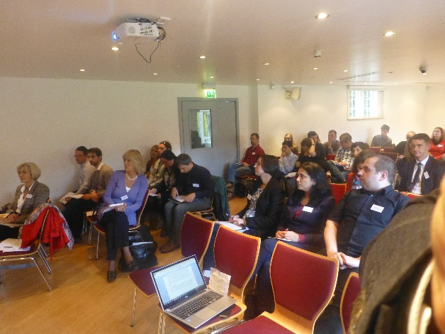
Mr Fadi Issa (Oxford) summarised the need for humanised mouse models and reviewed different strategies for their creation. He then summarised the use of humanised mouse models, created through reconstitution with peripheral blood mononuclear cells or haematopoietic stem cells, to study rejection of human skin and islets, development of allograft vasculopathy and the immunomodulatory efficacy of regulatory T cells. He concluded by describing some of the challenges that are yet to be resolved, including suboptimal antibody response generated in humanised mice. The PhD student from the group of Mr Kourosh Saeb-Parsy (Cambridge) then described the use of tissue from HLA-typed (‘DR4’) deceased human organ donors for the generation of both humanised mice and autologous (self) and allogeneic (non-self) stem cell-derived regenerative cellular therapies. She outlined
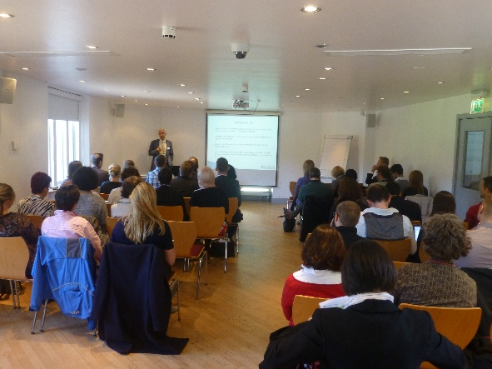
how this model is being utilised to study the immunogenicity of induced pluripotent stem cells and their progeny. Some of the challenges relating to the creation and characterisation of the humanised mice were outlined. Dr Fang Xiao (KCL) next described the generation of humanised mice using umbilical cord blood and outlined the ex vivo generation of regulatory T cells to prevent rejection of islets in a humanised mouse model. A novel approach, focused on inhibition of the complement cascade in prevention of rejection of islets was also explored. The session was concluded by Dr Aidan Synnott (Charles River) who outlined application of humanised mice to immuno-oncology and toxicology testing in models of melanoma and colorectal cancer. He described the development of a humanised mouse model in which human tumours are not rejected and can therefore be used to test therapeutic efficacy of different treatment strategies.
Novel technologies in humanised mouse research
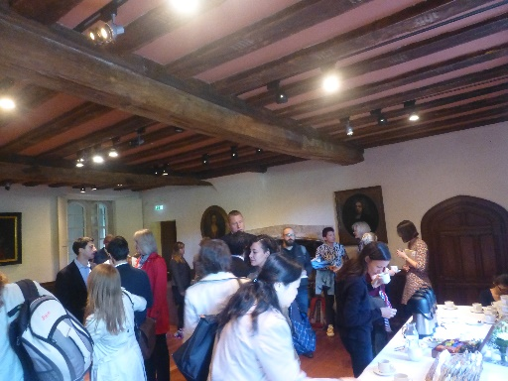
Dr Brian Soper (Jackson Laboratories) presented a webinar overview of the human innate and adaptive immune system, followed by details of the main humanised mouse models in current use or under development. Some of the challenges relating to adequate engraftment and competence of the innate and immune compartments were also described. The webinar was concluded by describing some of the applications of humanised mouse models to the study of infections, vaccines and oncology. Dr Henrique Veiga-Fernandes (StemCell2MAX) described the physiological niche for the development of haematopoietic stem cells and outlined studies which demonstrate the importance of neurotrophic factors for the maintenance of ‘stemness’ in these cells. He concluded by presenting data which demonstrated how these factors were successfully used for the expansion of HSCs from mouse bone marrow and human umbilical cord blood. Miss Yvonne Diener (Miltenyi Biotec) concluded the session by summarizing some of the strategies available for the isolation of HSCs. She described studies which aimed to modulate gene expression in HSCs using lipofection or electroporation of siRNA, demonstrating the superiority of the latter approach.
Experimental applications of humanised mice
Dr Marcus Dorner (Imperial College London) opened the session by describing the application of different humanised mouse models to study of the immune response to viral infections, including development of vaccines. He summarized that there was some evidence of vaccine mediated protection although further optimization of the model was necessary. He concluded by describing a method for ‘humanisation’ of the mouse liver by replacement of mouse hepatocytes with human cells. Miss Kate Milward (Oxford) described the abrogation of rejection of human skin using regulatory T cells in a humanised mouse model. GFP-tagged regulatory T cells could be detected infiltrating skin transplants and were shown to be sufficient in preventing rejection in re-transplant models. Dr Sarah Howlett (Cambridge) described the generation of humanised mice to study autoimmunity. The use of different IL-2 protein constructs to shift the balance between effector and regulatory T cells was described, including the assessment of the functional efficacy of the regulatory cells in a humanised mouse model. Mr Dominic Boardman (KCL) described a protocol for the expansion of regulatory T cells from human donors. He described the creation of chimeric antigen receptors and their potential utility for the generation of allospecific regulatory T cells and outlined experiments providing
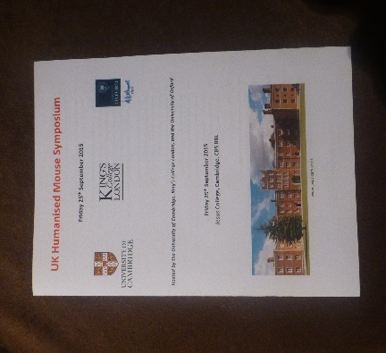
evidence for their suppressive efficacy. The session was concluded by Dr Cristiano Scotta (KCL) who described the generation of ex vivo expanded polyclonal regulatory T cells for kidney transplant recipients. Using a humanised mouse model, he described a study which confirmed immunosuppression does not adversely affect the number or efficacy of regulatory T cells or trafficking of lymphocytes, thus confirming their potential for use in transplant recipients receiving immunosuppressive agents.
Summary and conclusion
Mr Kourosh Saeb-Parsy (Cambridge) expressed his gratitude to his colleagues from Cambridge, Oxford and KCL for their help in organising a very informative meeting. He also expressed his gratitude to all the speakers and sponsors of the meeting. He announced that the 2016 UK Humanised Mouse Symposium was scheduled to take place on Friday 23rd September 2016 in Cambridge.
2015 Symposium Sponsors

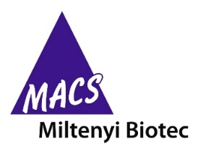

2016 UK Humanised Mouse Symposium

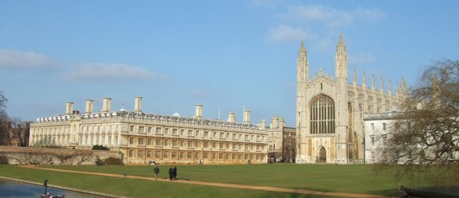

Friday 23rd September 2016
Fitzwilliam College, Cambridge, CB3 0DG

Contact:
Kourosh Saeb-Parsy (ks10014@cam.ac.uk)

Delegate Contact
Giorgio Anselmi giorgio.anselmi@kcl.ac.uk
Dominic Boardman dominic.boardman@kcl.ac.uk
Dr Eleanor Bolton emb34@cam.ac.uk
Maria Brandão de Vasconcelos mbv@stemcell2max.com
Dr. Alejandra Bruna Alejandra.Bruna@cruk.cam.ac.uk
Emily Calderbank ec568@medschl.cam.ac.uk
Mr John Cassidy John.Cassidy@cruk.cam.ac.uk
Amanda Dalby ald45@cam.ac.uk
Yvonne Diener
Dr Marcus Dorner m.dorner@imperial.ac.uk
Dr. Raul A. Elgueta raul.elgueta@kcl.ac.uk
Prof Gerard Evans gie20@cam.ac.uk
Nikitas Georgakopoulos ng395@cam.ac.uk
Michele Giroux michele@miltenyibiotec.co.uk
Dr Joanna Hester joanna.hester@nds.ox.ac.uk
Tom Holder tholder@UAR.ORG.UK
Ian Holyer ian.x.holyer@gsk.com
Dr Sarah Howlett sarah.howlett@cimr.cam.ac.uk
Anna Hows annaj@miltenyibiotec.co.uk
Mr Fadi Issa fadi.issa@nds.ox.ac.uk
Samuel Jameson slj36@cam.ac.uk
Lorna Jarvis lbd20@medschl.cam.ac.uk
Dr Joanne Jones jls53@medschl.cam.ac.uk
Prof Giovanna Lombardi Giovanna.lombardi@kcl.ac.uk
Dr. Wei-Yu Lu w.y.lu@ed.ac.uk
Dr. Krishnaa Mahbubani ktam2@cam.ac.uk
Dr Emma Martinez esanchez@eara.eu
Miss Kate Milward kate.milward@nds.ox.ac.uk
Dr. Thomas Moreau tm384@cam.ac.uk
Dr. Annett Mueller am2374@medschl.cam.ac.uk
Dr Larry Patterson larry.peterson@cimr.cam.ac.uk
Caroline Peters caroline.x.peters@gsk.com
Mr Gavin Pettigrew gjp25@cam.ac.uk
Elly Rankin ellyr@miltenyibiotec.co.uk
Dr. Alasdair Russell Alasdair.Russell@cruk.cam.ac.uk
Dr Fouzia Sadiq f.sadiq@imperial.ac.uk
Mr Kourosh Saeb-Parsy ks10014@cam.ac.uk
Antonella Santoro as2550@cam.ac.uk
Christiano Scotta cristiano.scotta@kcl.ac.uk
Dr. Amita Shortland as824@cam.ac.uk
Cameron F Smith cameron.f.smith@crl.com
Dr Brian Soper
Aidan Synnott Aidan.Synnott@crl.com
Sally-Anne Thomas sat55@cam.ac.uk
Olivia Tysoe O.Tysoe@warwick.ac.uk
Dr Henrique Veiga-Fernandes jhfernandes@medicina.ulisboa.pt
Dr. Maria Vias maria.vias@cruk.cam.ac.uk
Dr Martin Vinell martin.vinnell@admin.cam.ac.uk
Mark Wurdeman Mark.Wurdemann@crl.com
Dr. Fang Xiao fang.xiao@kcl.ac.uk

